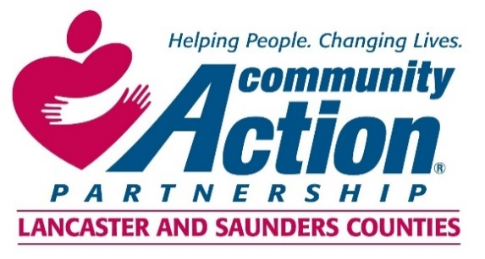

***Community Action Partnership of Lancaster and Saunders Counties is a private,***

***not-for-profit organization with the belief that extraordinary employees have the power to***

***positively transform lives and communities. We value people who are passionate, ethical,***

***and dedicated to empowering those living in poverty to reach economic stability.***

**Early Head Start and Head Start Instructional Coach**

The Instructional Coach will be responsible for facilitating full and effective implementation of evidenced-based instructional practices to continuously improve teaching and learning. With the aim of accelerating children’s learning, development, and school readiness outcomes, the Instructional Coach provides leadership in:

1. the design, delivery, and coordination of intensive professional development and practice based coaching;
2. education program development;
3. facilitation of interdisciplinary collaboration; and
4. administrative support

Bachelor’s degree in Early Childhood Education, Child Development, or closely related field required (Master’s degree preferred). Extensive experience working in center-based early childhood programs required. At least one year of experience serving in a coaching/supervisory capacity required. Experience providing professional development to classroom teachers preferred. Experience working with low-income or other vulnerable populations strongly preferred. Strong verbal and written proficiencies of the English language required. Valid Nebraska Driver’s License and good driving record preferred.

You will find complete job listings and details at the following websites:

[*www.Communityactionatwork.org*](http://www.Communityactionatwork.org)

[*www.indeed.com*](http://www.indeed.com)

[*www.NeWorks.nebraska.gov*](http://www.NeWorks.nebraska.gov)

**For information regarding benefits please contact Human Resources at 402-875-9315 or**

[**mandrews@communityactionatwork.org**](mailto:mandrews@communityactionatwork.org)

**Resumes and cover letters should be sent to:**

[**mandrews@communityactionatwork.org**](mailto:mandrews@communityactionatwork.org)

**\*\*\***

Community Action Partnership of Lancaster and Saunders Counties is an equal opportunity employer and does not discriminate on the basis of race, color, religion, national origin, marital status, veteran status, political affiliation, sexual orientation or gender identity, disability, sex, age or any other status protected by state or federal law.

