**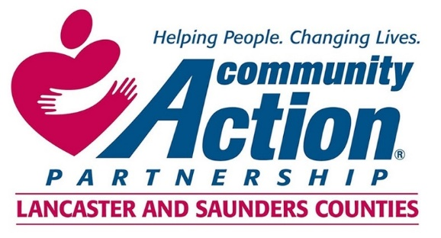 

***Community Action Partnership of Lancaster and Saunders Counties is a private,***

***not-for-profit organization with the belief that extraordinary employees have the power to***

***positively transform lives and communities. We value people who are passionate, ethical,***

***and dedicated to empowering those living in poverty to reach economic stability.***

**Head Start Site Coordinator**

Community Action is looking for its next dynamic early childhood leader to guide a team in its work to provide high caliber early childhood education and develop genuine partnerships with parents to promote healthy child development. The Head Start Site Coordinator will be responsible for leading the implementation of Head Start standards and practices in a full day, full year early childhood education center. The Head Start Site Coordinator will work closely with the interdisciplinary Head Start management team to help ensure full implementation of regulations, program policies, and quality early child educational services to enrolled children and their families. Responsible for supervision of Lead Teachers and ensuring positive family engagement in children’s center-based education. Responsible for coordinating classroom staffing and scheduling. Spearheads recruitment and hiring of teaching staff.

Minimum ofan Associate’s or Bachelor’s degree in Early Childhood Education, Child, Youth, and Family Studies or a closely related field required. At least four years’ experience working in early childhood development-related field and at least one year in a center-based preschool environment required. Minimum one year of supervisory experience required. Experience with Head Start, NAEYC Accreditation, or program similar in rigor preferred. Experience working with low-income families and families with diverse backgrounds and cultures required.Strong verbal and written proficiencies of the English language required.

You will find complete job listings and details at the following websites:

[*www.Communityactionatwork.org*](http://www.Communityactionatwork.org)

[*www.indeed.com*](http://www.indeed.com)

[*www.NeWorks.nebraska.gov*](http://www.NeWorks.nebraska.gov)

**For additional information contact Human Resources at**

**402-875-9315 or** [**mandrews@communityactionatwork.org**](mailto:mandrews@communityactionatwork.org)

**Resumes should be sent to** [**mandrews@communityactionatwork.org**](mailto:mandrews@communityactionatwork.org)

**\*\*\***

Community Action Partnership of Lancaster and Saunders Counties is an equal opportunity employer and does not discriminate on the basis of race, color, religion, sex (including pregnancy, sexual orientation, gender identity or expression), national origin, disability, age, protected veteran status, marital status, genetics, or any other status protected under federal and state law.