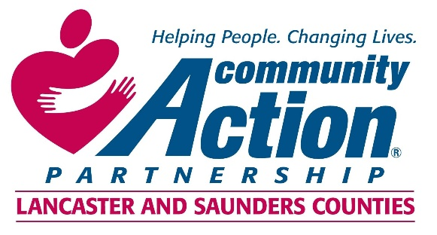

Community Action Partnership of Lancaster and Saunders Counties is a private,
not-for-profit organization with the belief that extraordinary employees have the power to
positively transform lives and communities. We value people who are passionate, ethical,
and dedicated to empowering those living in poverty to reach economic stability.

Early Head Start and Head Start Instructional Coach

The Instructional Coach will be responsible for facilitating full and effective implementation of practice-based coaching to continuously improve teaching and learning. With the aim of accelerating children’s learning, development, and school readiness outcomes, the Instructional Coach provides leadership in:

- the design, delivery and coordination of intensive professional development;
- education program development;
- facilitation of interdisciplinary collaboration; and
- administrative support

Bachelor’s degree in Early Childhood Education, Child Development, or closely related field

required (Master’s degree preferred). Previous Early Childhood Education supervisory

experience strongly preferred. Extensive experience working in center-based Early Childhood

programs required. Experience providing professional development to classroom teachers

preferred.

For information regarding benefits please contact Human Resources at 402-875-9315 or
mandrews@communityactionatwork.org

Resumes and cover letters should be sent to:
mandrews@communityactionatwork.org

***

Community Action Partnership of Lancaster and Saunders Counties is an equal opportunity employer and does not discriminate on the basis of race, color, religion, national origin, marital status, veteran status, political affiliation, sexual orientation or gender identity, disability, sex, age or any other status protected by state or federal law.

